Natasha Koopstra

**Report – CO2-emissions**

Introduction

We have suffered from a strong greenhouse effect on Earth for quite some time now. The temperature rise that is the consequence causes big problems for the world. One of the leading greenhouse gases contributing to this is carbon dioxide (CO2). In recent decades, there has been a significant increase in CO2 in the atmosphere and CO2 emissions must be reduced.

This study aims to obtain answers to the following questions:

1. What is the biggest predictor of a large CO2 output per capita of a country?

2. Which countries are making the biggest strides in decreasing CO2 output?

3. Which non-fossil fuel energy technology will have the best price in the future?

**Analysis 1.**

Biggest predictor CO2-emission

Method

To answer the question: “What is the biggest predictor of a high CO-emission per capita of country?”, data is used derived from “Our World in Data (<https://ourworldindata.org/>). Here I found information about the so called “Kaya Identity”.

The Kaya identity is a mathematical identity stating that the total emission level of the greenhouse gas carbon dioxide can be expressed as the product of four factors:

* Human population
* GDP per capita
* Energy intensity (per unit of GDP)
* Carbon intensity (emissions per unit of energy consumed)

To assess a correlation between the predictive factor and CO2 emissions, the Pearson correlation coefficient (r) is used. The interpretation of the value is based on the classification of Rea and Parker (2014). See table below.

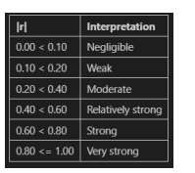

*Table 1: Classification of the Pearson correlation coefficient of Rea and Parker (2014)*

It is undoubtedly true that demonstrating a correlation does not necessarily mean that there is a causal relationship!

Results

Below, the Pearson correlation coefficients are shown for the different investigated factors. One predicting factor appears to have the strongest positive correlation, namely Carbon intensity. See tables below.

*Table 2:* Human population

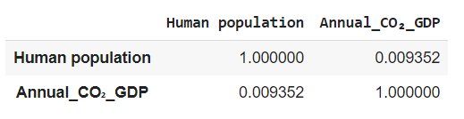

*Table 3:* GDP per capita

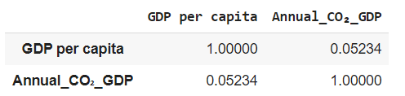

*Table 4:* Energy intensity (per unit of GDP)

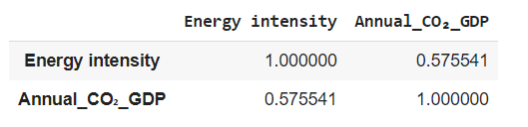

*Table 5:* Carbon intensity (emissions per unit of energy consumed)

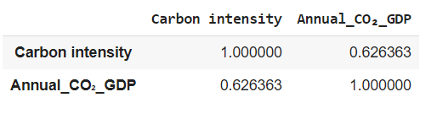

Next, I must determine if I have sufficient data to establish a significant correlation. To do this, I have examined the p-value.

Conclusion

Based on the correlation coefficient of 0.626 and a p-value of 0.0, we can conclude that there is a significant linear association between the two variables. When the p-value is below 0.5, we consider it as significant. Therefore, the biggest predictor of a country's large CO2 output per capita is carbon intensity. Carbon intensity is the grams of carbon dioxide (CO2) required to produce one unit of electricity per kilowatt-hour (kW/hour).

**Analysis 2.**

Decrease in CO2-output

Method

To answer the question: “Which countries are making the biggest strides in decreasing CO2 output?”, the following dataset is used from “Our World in Data: “Change in per capita CO2 emissions and GDP”. The data is presented on a per capita basis, which means that changes in population have already been factored in.

The analysis is focused on the time frame between 2000 and 2018, which has been chosen for its reliability in making statements about the development of CO2 emissions.

Results

When asked about the countries making progress in reducing CO2 emissions, the answer is that Yemen, Malta, and Syria are leading the way. The top 5 also includes Venezuela and North Macedonia.

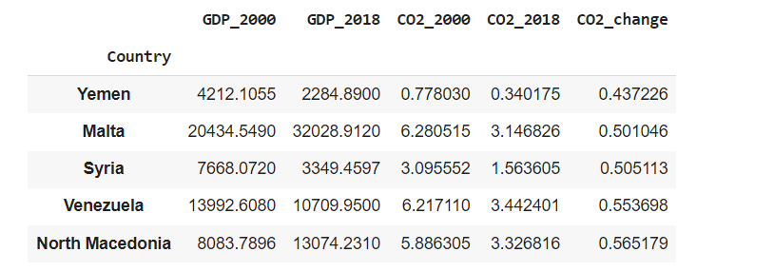

*Table 6: Top 5 countries reducing CO2.*

It is interesting to find out which relation exists between the GDP and the CO2 emission. Was a country capable of reducing its CO2 emission and realising growth in its GDP at the same time?

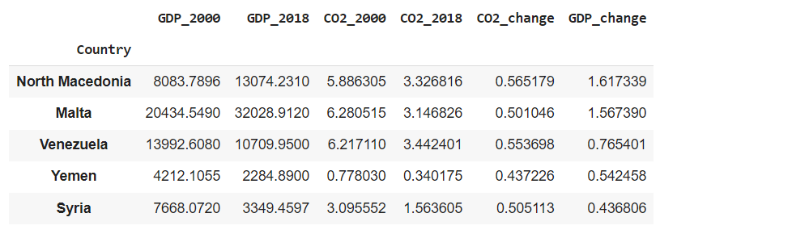

*Table 7: Top 5 countries reducing CO2 and GDP growth.*

Conclusion

It can be concluded that Yemen experienced the highest decrease in CO2 emissions, but it was coupled with a nearly 50% reduction in their GDP per capita. The same situation occurred in Syria. However, North Macedonia and Malta's accomplishment is relatively more impressive since they were able to decrease CO2 emissions while simultaneously achieving substantial GDP growth.

**Analysis 3.**

Non-fossil Energy Sources

Method

According to the given task, to make price predictions, linear regression might be necessary for alternatives to fossil fuels. While conducting research in “Our World in Data, I came across a table titled 'Levelized cost of energy by technology, World' (LCOE). This table displays the approximate average cost per energy unit produced throughout the lifespan of a new power plant. It is denominated in US dollars for six different energy sources: concentrated solar power, offshore wind, bioenergy, solar energy, hydropower, and onshore wind.

Results

The figure below shows the different linear regression lines based on the regression model. Looking at the year 2033, solar photovoltaics will reach the lowest price compared to all the other energy sources. Moreover, the slope of this source is also the most negative.

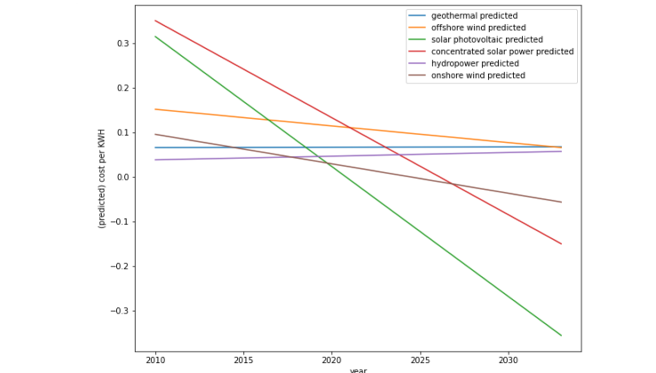

*Figure1: Linear regression lines of the different non-fossil energy sources*

Conclusion

Based on the figure provided, solar photovoltaic energy technology will have the most competitive price in the future amongst non-fossil fuel energy sources. This is due to its lower cost than other non-fossil fuel energy sources, which suggests it will likely be more affordable in the future. Therefore, solar photovoltaic technology is the most promising option for cost-effective non-fossil fuel energy.